Project Submission on Pharmaceutical Management System



**Name: Ashraful Sarker**

**Roll: 05-003-20**

**Project: Pharmaceutical Management System**

A database for a pharmaceutical management system with ER diagram and requiring steps-

# STEP 01 and 02: Identifying the Entities and the Attributes and Primary key for each Entity required.

1. Customers (**customer_id**, name, email, phone_number, address, date_of_birth, gender, profession, medical_history)
2. Suppliers (**supplier_id**, name, contact_person, phone, email, address, license_number)
3. Medications (**medication_id**, name, description, barcode, batch_number, unit_price, expiry_date)
4. Prescriptions (**prescription_id,** prescription_date**,** doctor_name**,** doctor_contact**,** notes)
5. Prescription_Items (**prescription_item_id**, dosage, quantity, instructions)
6. Sales (**sale_id**, sale_date, total_amount, payment_method)
7. Employees (**employee_id**, name, email, phone, address, position, salary, hire_date)
8. Shift_Schedules (**shift_id**, shift_name, start_time, end_time)
9. Store_branches (**branch_id**, address, phone_number, duration)
10. Purchases (**purchase_id**, quantity, cost_price)
11. Expenses (**expense_id**, expense_date, amount, description, category)

# Step 03 and 04: Identifying the relationship between entities and cardinality ratio and participation needed

1. **Suppliers -**provide**-Medications**

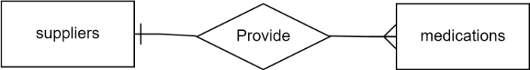

1. **Customers** -have- **Prescriptions**

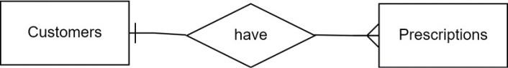

1. **Prescription -**contain- **Prescription_items**

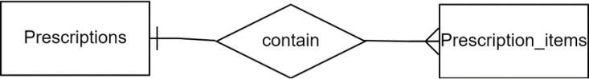

1. **Prescription_items -**contain- **Medications**

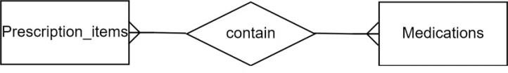

1. **Sales -**belong to- **Customers**

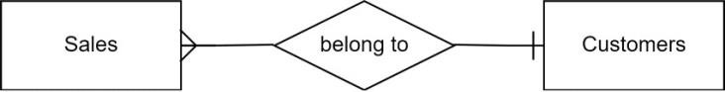

1. **Shift_schedules -**assigned to- **Employees**

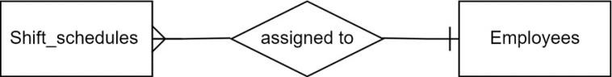

1. **Store_branches -**allocated to- **Employees**

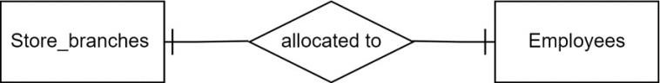

1. **Purchase -**belongs to- **Suppliers**

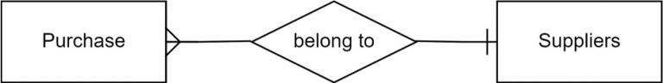

1. **Purchase -**contains- **Medications**

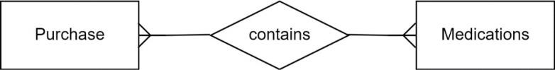

# Step 05: Drawing the Entity- Relationship Diagram (ERD)

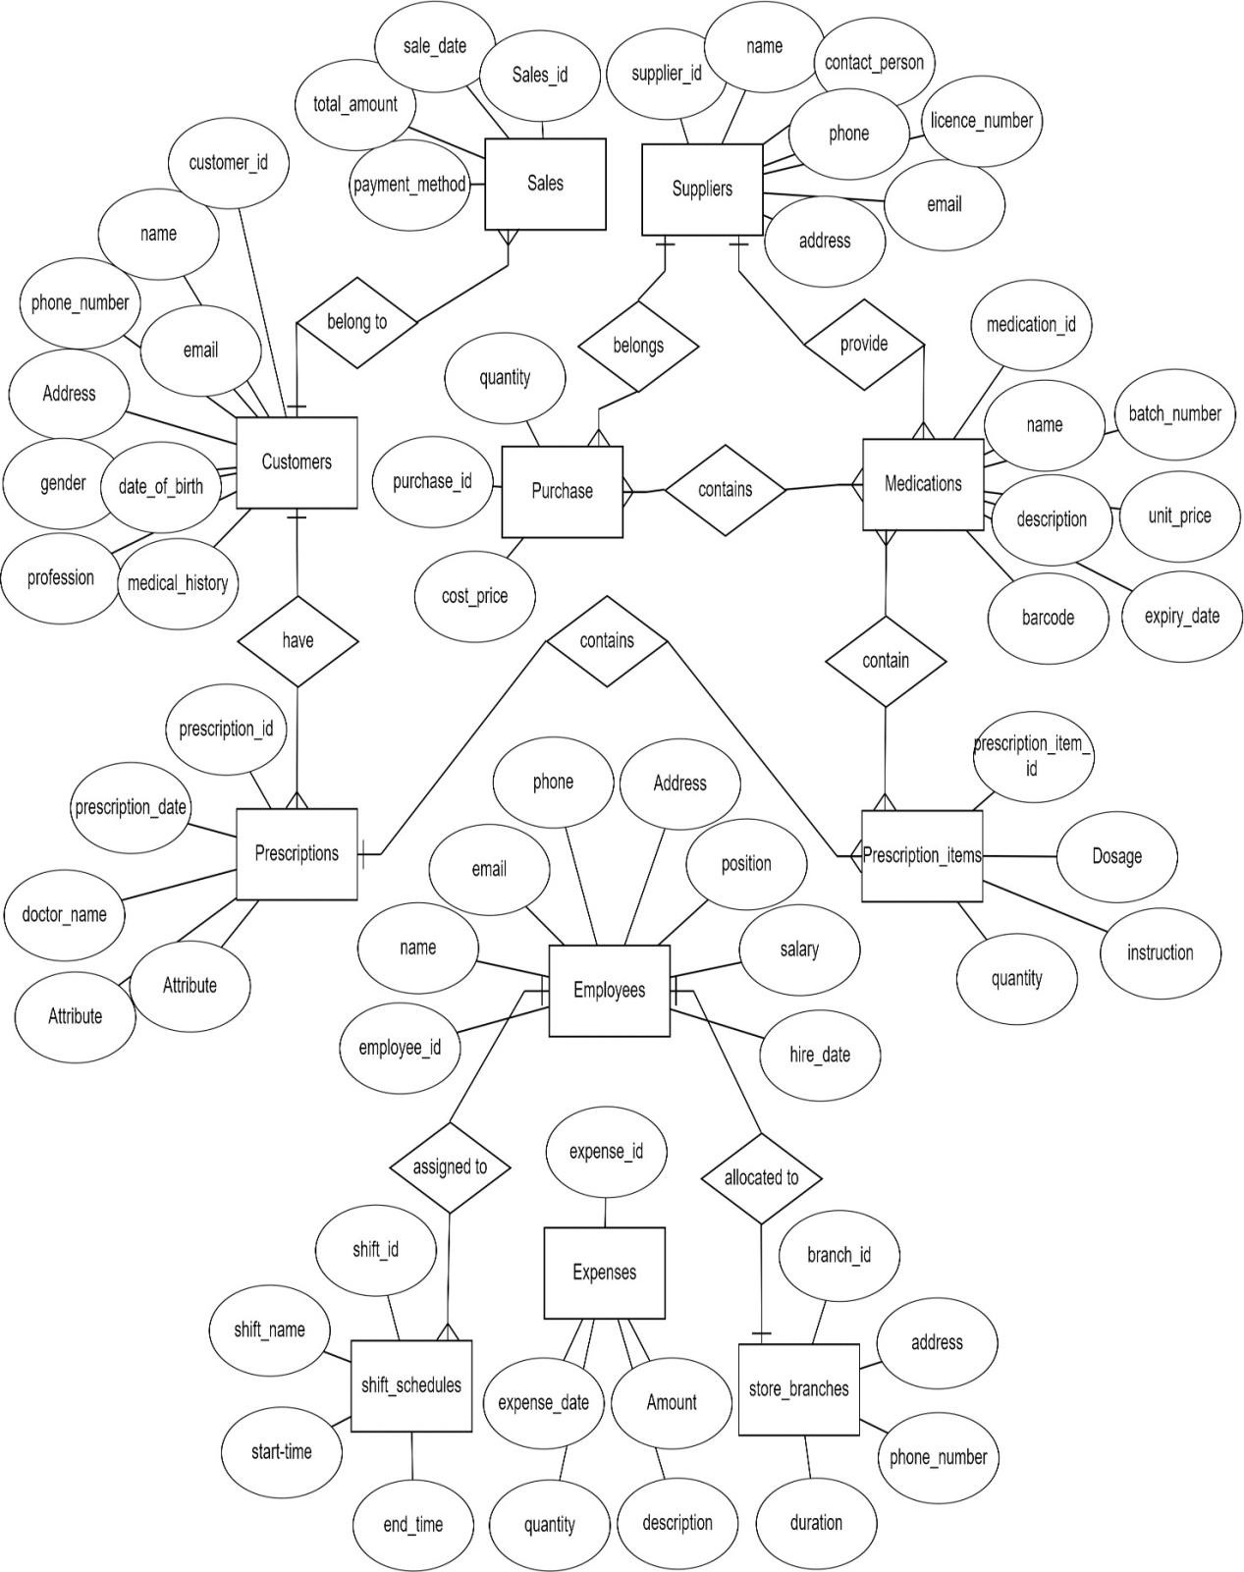

**Reduction to Database Schema**

1. Customers (**customer_id**, name, email, phone_number, address, date_of_birth, gender, profession, medical_history)
2. Suppliers (**supplier_id**, name, contact_person, phone, email, address, license_number)
3. Medications (**medication_id**, supplier_id, name, description, barcode, batch_number, unit_price, expiry_date)
4. Prescriptions (**prescription_id,** customer_id**,** prescription_date**,** doctor_name**,** doctor_contact**,** notes)
5. Prescription_Items (**prescription_item_id**, prescription_id, medication_id, dosage, quantity, instructions)
6. Sales (**sale_id**, customer_id, sale_date, total_amount, payment_method)
7. Employees (**employee_id**, name, email, phone, address, position, salary, hire_date)
8. Shift_Schedules (**shift_id**, employee_id, shift_name, start_time, end_time)
9. Store_branches (**branch_id**, employee_id, address, phone_number, duration)
10. Purchases (**purchase_id**, supplier_id, medication_id, quantity, cost_price)
11. Expenses (**expense_id**, expense_date, amount, description, category)

